GCNU1003 Speaking of Statistics (1004) - Assignment 4
Chapter 5
- Suppose that the probability distribution of a random variable x can be described by the formula 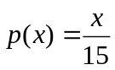
for each of the values X=1,2,3,4, and 5. For example, then 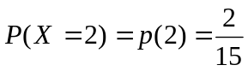.
a. Write out the probability distribution table of x.
b. Show that the probability distribution of x satisfies the properties of a discrete probability distribution.
c. Calculate the mean of x.
d. Calculate the variance,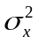, and the standard deviation, 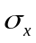.
Ans
a. x 1 2 3 4 5
p(x) 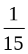 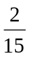 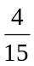
b. p(x) ≥ 0 for each value of x.
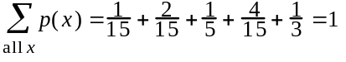
c.
d.

- The J.O. Supplies Company buys calculators from a Korean supplier. The probability of a defective calculator is 10%.
- If 10 calculators are selected at random, what is the probability that 3 or more of the calculators will be defective?
- If 100 calculators are selected at random, what are the mean and the standard deviation of the number of defectives?

Ans: a.0.0702
P(X≥3)=1–P(X≤2)=1-.9298=.0702
b. E[X]= 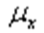 =(.10)(100)=10
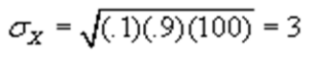

- Historical data shows that the average number of patient arrivals at the intensive care unit of General Hospital is 3 patients every 2 hours. Assume that the patient arrivals are distributed according to Poisson distribution.
a. Determine the probability of 6 patients arriving in a five-hour period.
b. Determine the probability of at least 4 but no more than 8 patients arriving in a three-hour period.
Ans: 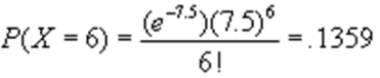
P(4≤X≤8)=P(X=8)+P(X=7)+P(X=6)+P(X=5)+P(X=4)
P(4≤X≤8)=(.0463)+(.0824)+(.1281)+(.1708)+(.1898)=.6174

- An insurance company will insure a $75,000 Hummer for its full value against theft at a premium of $1500 per year. Suppose that the probability that the Hummer will be stolen is 0.0075.
- Calculate the insurance company's expected net profit.
- Find the premium that the insurance company should charge if its wants its expected net profit to be $2000?

Ans:
a.
b.2000=(x-75000)(.0075)+x(.9925)=.0075x–562.5+.9925
x=2562.5

- The Post Office has established a record in a major mid-western city for delivering 90 percent of its local mail the next working day. If you mail eight local letters,
- What is the probability that all of them will be delivered the next day?
- Calculate the average and standard deviation of the number delivered.
- What is the probability that the number of delivered will be within 2 standard deviations of the mean

Ans: a. P(x = 8) = .4305
b. 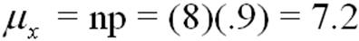
c. P(σ = 7.2 ± 2(.85)) = P(σ = 7.2 ± 1.7) = P(5.5 ≤ x ≤ 8) = P(6 ≤ x ≤ 8) = (.4305) + (.3826) + (.1488) = .9619

